Experiment 1

Circuit Diagram:

*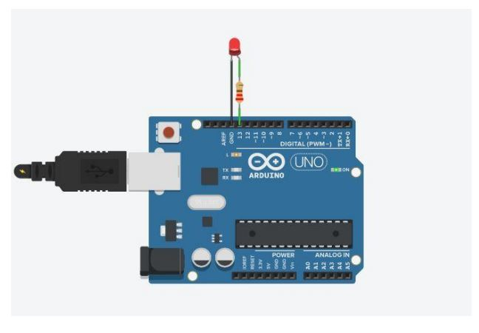*

*Theory:*

Concept used:

Various concepts are used in this experiment as listed:

1. The Light emitting Diode
2. Connection of Arduino Uno circuit board
3. Coding of arduino uno

Learning and Observations:

In this experiment we learnt about:

1. Basic coding used in Arduino Uno.
2. Connecting LED with Arduino Uno board.

Observations:

1. If we change the delay to any other value, the blinking of LED is also change according to the value of delay.

Precautions:

1. The circuit’s elements should be properly connected.
2. The LED should be connected in proper orientation i.e. negative terminal of LED should be connected to the ground pin.
3. Ports should be declared properly.

Learning Outcomes:

From this experiment we learn and acquire skills about:

1. Working of Arduino along with the LED.
2. Application of digital pins of Arduino Uno Board.